LAB - 2
CSL 203

Karthik Krishnan
Roll No: 45
S3 CSE B
26-07-2024
Friday
Experiment No: 2
Frequency of a Character in a String
- Write a Java Program to find the frequency of a given character in a string.
- String -Use of charAt()

Expected Output:
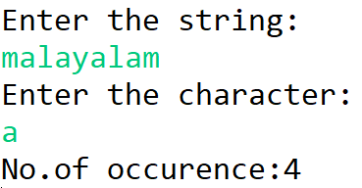

Answer:

Experiment No: 4
Method Overloading

Expected Output:
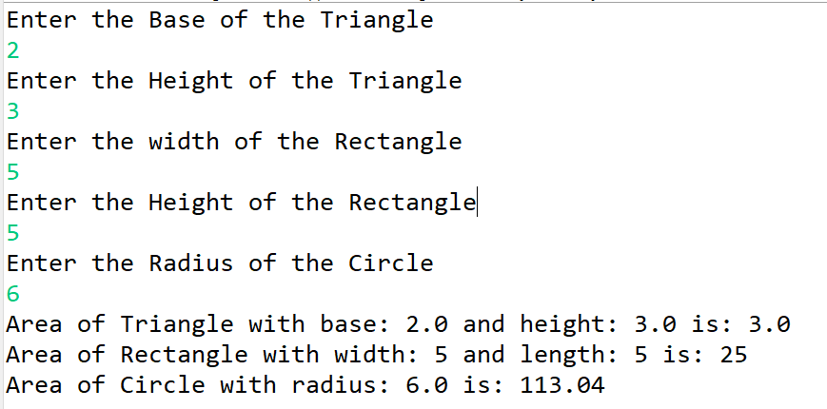

Answer:

